**Pin configuration**

**Master ESP8266 Pin Configuration**

1. **OLED Display**:
   * **SDA (Data Line)**: GPIO 4 (D2)
   * **SCL (Clock Line)**: GPIO 5 (D1)
2. **I2C Communication with Slave**:
   * **SDA**: GPIO 4 (D2) - same as OLED
   * **SCL**: GPIO 5 (D1) - same as OLED
3. **Other Pins**:
   * **VCC**: 3.3V
   * **GND**: GND

**Slave ESP8266 Pin Configuration**

1. **Touch Sensor**:
   * **Touch Sensor Signal Pin**: GPIO 14 (D5)
   * **Touch Sensor VCC**: 3.3V
   * **Touch Sensor GND**: GND
2. **I2C Communication with Master**:
   * **SDA**: GPIO 4 (D2) - same as Master
   * **SCL**: GPIO 5 (D1) - same as Master
3. **Other Pins**:
   * **VCC**: 3.3V
   * **GND**: GND

**Wiring Diagram**

**Master ESP8266 to OLED Display and Slave ESP8266**

* **OLED Display**:
  + **VCC** to **3.3V** (Master ESP8266)
  + **GND** to **GND** (Master ESP8266)
  + **SDA** to **GPIO 4 (D2)**
  + **SCL** to **GPIO 5 (D1)**
* **I2C Communication** (with Slave ESP8266):
  + **SDA** (Master) to **SDA** (Slave)
  + **SCL** (Master) to **SCL** (Slave)
* **Common Ground**: Connect the GND of both ESP8266 devices together to ensure proper communication.

**Slave ESP8266 to Touch Sensor**

* **Touch Sensor**:
  + **VCC** to **3.3V** (Slave ESP8266)
  + **GND** to **GND** (Slave ESP8266)
  + **Signal Pin** to **GPIO 14 (D5)**

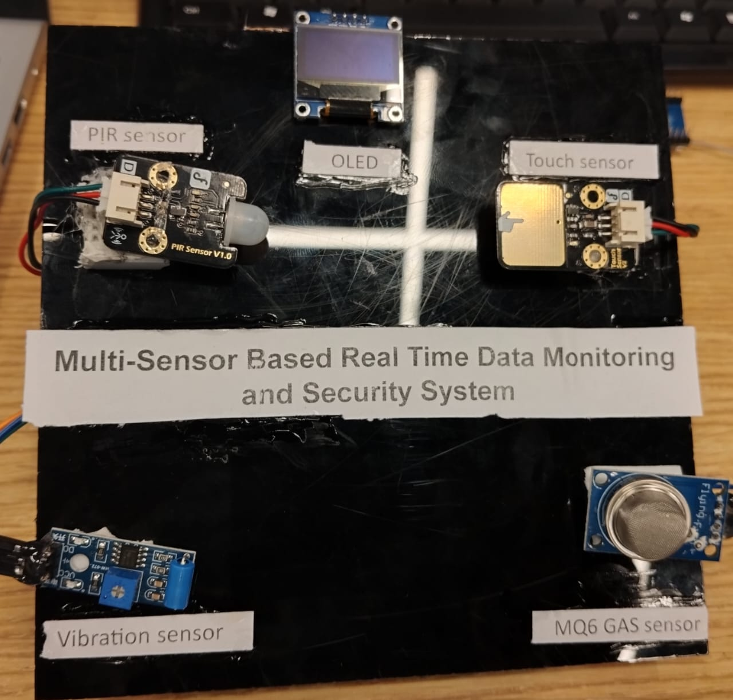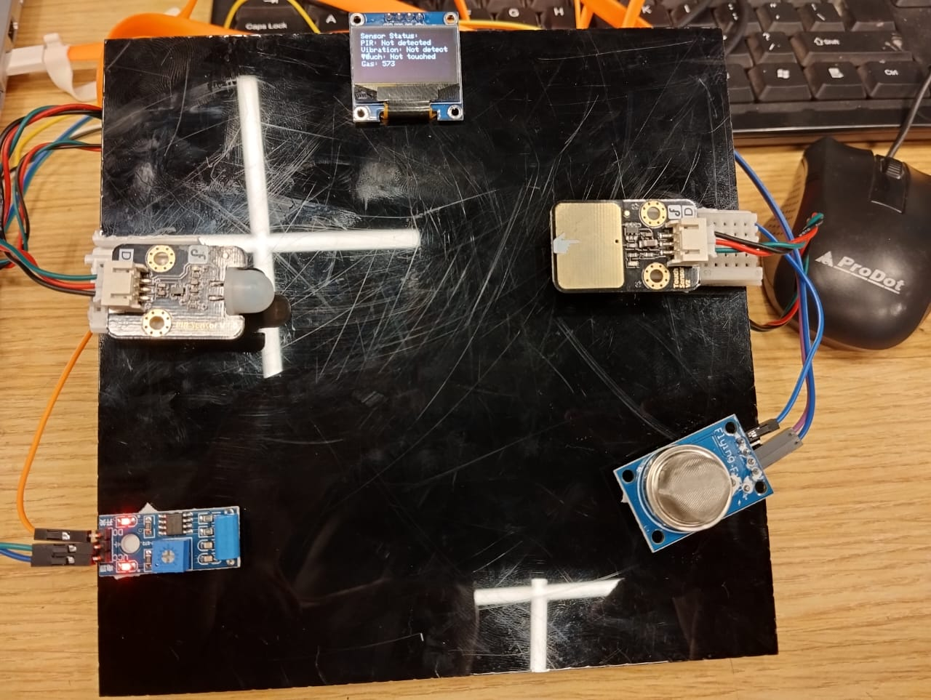

Also using Blynk cloud for better enhancement and efficiency.